|  |
| --- |
|  |



**7 December 2012** **The Weekly Bulletin of Rotary Club of Kathmandu Mid-Town** **Bc-7.12/012-13**

District : 3292 Web:www.rotarymidtown.org.np Club Id : 26776

**DECEMBER IS THE FAMILY MONTH**

Rotarians, clubs, and districts worldwide are encouraged to demonstrate their commitment to family and community through projects, activities, and events in celebration of Family Month .

Friday, 30 November:

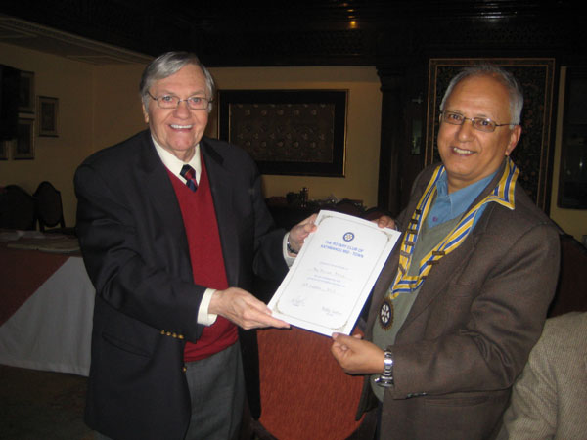

Mr. William Bodde, Guest Speaker, shared with the Club members,

the knowledge and wisdom garnered through many years of his

diplomatic service. He recalled being impressed, during his visit to

the Club 15 years ago, by the fact that the Club had a Lady President,

Dr Chandra Lekha Tuladhar, in the chair which he felt would have been

a rarity in the US in those days. He also noted that Nepal has, in spite

of continuing intransigence in some areas of its administration, made a

lot of socio-economic progress. He highlighted, as one of the pleasant

cultural differences that he experienced during his first visit to Nepal,

the embracing warmth and friendliness and touching innocence of the

people of Nepal. It was a rare opportunity for the Club members of interacting with members of a family cutting across three generations – father, son and grandson; Guest Speaker William Bodde, his son Rtn Peter Bodde (Club member) and Peter's son Chris. In the picture President Devendra handing over a certificate of appreciation to the Guest Speaker.

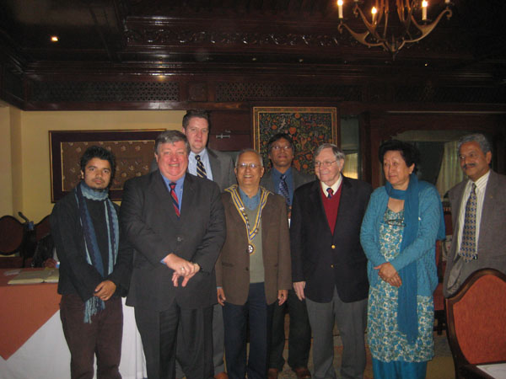

Three generation group photo with President Devendra, PP Lekha and PP Pratap, Secretary Buddha and Rtr Kishore

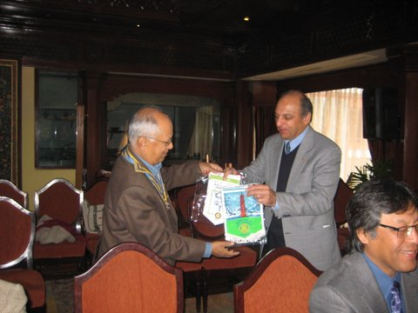

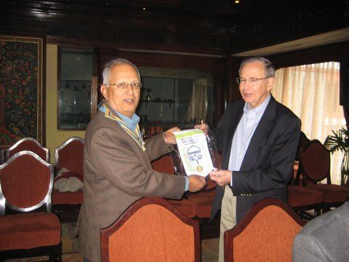

President Devendra exchanging club banners with visiting Rotarians Salim Laher and Fred Grover.

# Weekly Meetings and Programs :

|  |  |  |
| --- | --- | --- |
| Date | Program/Speaker | Program/Topics of Presentation |
| 7 Dec 2012 | Darshan Rauniyar | A Nepali-American's experience of running in US Congressional election, and some perspectives on Nepal |
| 14 Dec 2012 |  |  |

Friday, 7 December:

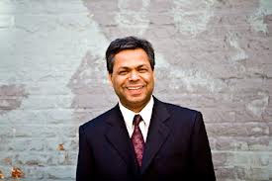

Mr. Darshan Rauniyar, a Nepali business professional, a naturalized US citizen, will be

providing some insights on his experience of running in US Congressional election.

Mr. Darshan was the first Nepali ever to run for the United States House of

Representative in Washington State’s 1st Congressional district in 2012.

**PP Ambica receives "Service Above Self Award:**

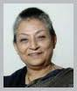

**Congratulations !!**

The Rotary International "Service Above Self Award" was awarded this year to PP Ambica.

This internationally competitive award is granted to only a  maximum of 150 Rotarians

per year who are examples of Service Above Self.

The nominee for this award must have demonstrated exemplary humanitarian service, in any form and at any level, with an emphasis on personal volunteer efforts and active involvement in helping others through Rotary. Mid-Town delights in this accolade and extends its heartiest congratulations to PP Ambica!

*courtesy:* Rtn Dr Isabella CB Khadka

**The annual Rotary-UN Day:**

During the opening panel, RI President Sakuji Tanaka said the relationship between the two organizations is a natural and enduring connection because both are committed to peace.

“I truly believe that the world today is a better place with Rotary and the United nations in it,” Tanaka said. “Neither the United Nations nor Rotary is in a position to solve all of humanity’s problems. But that is not our goal. Our goal is simply to make things better. We take what we have, and do what we can.”

Tanaka, who chose the RI theme of *Peace Through Service* for his year in office, said there is a connection between service and peace. “It has to do with caring for other people and understanding their needs.”

“When we recognize that the purpose of our lives is being helpful to others, it changes the way we feel about other people,” he said. “If our goal is service, we do not want to argue or fight. We want to live together in peace, and have greater inner peace ourselves.”

*Source:*Rotary International News

*Through our Rotary service, we know that cooperation is more productive than*

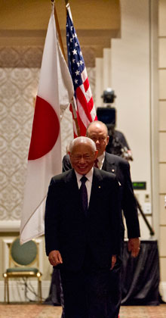

*conflict. We learn to value each other, as human beings with human strengths and*

*weaknesses. We know that every one of us has something to give, and everyone has*

*something to teach.*

**RI President Sakuji Tanaka**

On Lighter Side :

Click here ⇩



**A THOUGHT FOR THE DAY:**

**There is a wonderful mythical law of nature that three things that we crave for most in life: *Happiness, Freedom, and Peace of mind*,**

**are always attained by giving them to someone else.**

**Let us all share our happiness !**

**Great Quotes:**

***Comparison is the Best Way to Judge Your Progress!***

***But don't Compare with Others.***

***Just Compare Your Yesterday With Your Today !!***

**Do you know ?**

*Have you heard of ‘Liliger’ ?*

*A new kind of animal, called a ‘liliger’,*

*a cross between a lion and a liger has been born in Russia.*

*Her dad is an African lion but her mum is a liger – a cross between a lion and a tiger, making her the world’s first known ‘liliger’.*

*The baby big cat has been named Kiara.*

*Kiara is fed milk by her keepers and she gets motherly love from an ordinary domestic cat.*

*Her mother cann’t provide enough milk to feed her hungry cub.*

NB: If you have any information/photo that may be of interest to Rotarians send them to

BC Editor: RR Shrestha email: rryesrr@gmail.com

## 7 Dec 2012 The Weekly Bulletin of Rotary Club of Kathmandu Mid-Town bc-7.12/012-13